

# SIES (NERUL) COLLEGE OF ARTS, SCIENCE AND COMMERCE(AUTONOMOUS)

**NAAC RE-ACCREDITED ‘A’ GRADE**

**SRI CHANDRASEKARENDRA SARASWATI VIDYAPURAM,**

**PLOT-E, SECTOR-5,**

# NERUL, NAVI-MUMBAI-400706

# 

## SUBJECT – ADVANCED DEEP LEARNING

**PROJECT REPORT**

**IN**

## Image Captioning with Pretrained Model SUBMITTED BY

**Melwyn Titus John**

## MCS.23.11

**Under the Esteemed Guidance of**

**Dr. Rajeshri Shinkar**

## MCS.COMPUTER SCIENCE PART-2

**SEMESTER 4 (2024-2025)**



**SIES (NERUL) COLLEGE OF ARTS, SCIENCE AND COMMERCE(AUTONOMOUS)**

**NAAC RE-ACCREDITED ‘A’ GRADE**

**SRI CHANDRASEKARENDRA SARASWATI VIDYAPURAM,**

**PLOT-E, SECTOR-5,**

# NERUL, NAVI-MUMBAI-400706

**CERTIFICATE**

This is to certify that the project entitled **Image Captioning with Pre-trained Model** is successfully completed by **Melwyn Titus John** of Part-II (Sem-4) Masters in Science (Computer Science) as per the requirement. It is also to certify that this is the original work of the candidate done during the academic year 2024-2025.

**Roll no -** MCS.23.11 **Date of submission: 23-03-2025**

**Subject –** AdvancedDeep Learning

**Dr. Rajeshri Shinkar**

**(**project guide**)**

## INDEX

|  |  |
| --- | --- |
| **Sr. No.** | **Title** |
| 1 | Abstract |
| 2 | Introduction |
| 3 | Objectives |
| 4 | Literature Review |
| 5 | Methodology |
| 6 | Implementation |
| 7 | Results |
| 8 | Conclusion |
| 9 | References |

**Abstract**

Deep Learning has advanced the field of Computer Vision by enabling models to generate textual descriptions for images, a process known as *Image Captioning*.   
  
This project implements an image captioning system using a **pre-trained BLIP (Bootstrapping Language-Image Pre-training) model**. The model takes an image as input and generates a descriptive caption by leveraging **transformers and vision-language models**.   
  
The **Salesforce/blip-image-captioning-base** model is used to generate captions for images. The implementation involves loading an image, passing it through a pre-trained model, and obtaining a caption without requiring explicit feature extraction or annotation. This approach can be applied in **assistive technology, automated image description, and content tagging systems**.

**Keywords:** Deep Learning, Image Captioning, BLIP Model, Transformer-based Vision Models, Pre-trained Model

**Introduction**

Image Captioning is a fundamental task in **computer vision and natural language processing (NLP)**, where a system generates a meaningful textual description of an image. It has applications in **assistive technologies for visually impaired individuals, autonomous systems, and content-based image retrieval**.

Traditional image captioning relied on **CNN-RNN architectures**, where Convolutional Neural Networks (CNNs) extracted features, and Recurrent Neural Networks (RNNs) generated text. With the advancement of **Transformer-based models**, vision-language models like **BLIP (Bootstrapping Language-Image Pre-training)** offer a powerful way to generate captions efficiently.

This project focuses on implementing **BLIP-based image captioning** using a **pre-trained model** without requiring extensive training on custom datasets.

**Objectives**

1. To implement an **image captioning model** using a pre-trained deep learning model.
2. To utilize the **BLIP model** for generating captions from images.
3. To process image inputs and obtain meaningful descriptions.
4. To evaluate the performance of the generated captions.
5. To demonstrate the effectiveness of pre-trained vision-language models.

**Literature Review**

Image Captioning has evolved from early **template-based methods** to deep learning techniques involving **CNNs and RNNs**. Early models used **encoder-decoder architectures**, where CNNs encoded image features and RNNs (such as LSTMs) generated captions. However, these methods suffered from **context loss and lack of generalization**.

Recent advancements in **Vision Transformers (ViTs) and multimodal learning** have improved captioning accuracy. The **BLIP (Bootstrapping Language-Image Pretraining) model**, developed by Salesforce, uses a vision transformer to understand images and a language model to generate captions. It outperforms traditional CNN-RNN architectures and offers better generalization across datasets.

Pretrained models like **BLIP, CLIP, and ViLT** have set new benchmarks in **zero-shot learning for vision-language tasks**, making them ideal for **image captioning** without domain-specific training.

**Key Research Works:**

* Vaswani et al. (2017): Introduced the **Transformer model** for NLP.
* Radford et al. (2021): Developed **CLIP**, a vision-language model.
* Li et al. (2022): Proposed **BLIP**, a model for bootstrapping vision-language learning.

**Methodology**

The development of the Custom NER Model follows these steps:

**Pretrained Model:** Salesforce/blip-image-captioning-base

Libraries Used:

* torch: For deep learning operations
* transformers: For loading the BLIP model
* PIL (Pillow): For image processing

1. **Load the BLIP model and processor**

from transformers import BlipProcessor, BlipForConditionalGeneration

import torch

from PIL import Image

1. **Load an image and preprocess it**

image_path = "sample/sample.jpg" # Replace with your image path

image = Image.open(image_path).convert("RGB")

processor = BlipProcessor.from_pretrained("Salesforce/blip-image-captioning-base", use_fast=True)

1. **Generate the caption using the model**

model = BlipForConditionalGeneration.from_pretrained("Salesforce/blip-image-captioning-base")

inputs = processor(image, return_tensors="pt")

with torch.no_grad():

caption_ids = model.generate(**inputs)

caption = processor.batch_decode(caption_ids, skip_special_tokens=True)[0]

print("Generated Caption:", caption) return text for ent in annotations["entities"]:

ner.add_label(ent[2])

**Implementation**

The flow of execution follows:

1. Load the **pre-trained BLIP model**.
2. Read and process an image.
3. Convert the image into a tensor format for input to the model.
4. Generate a **text caption** using the model.
5. Display the generated caption.

**Results**

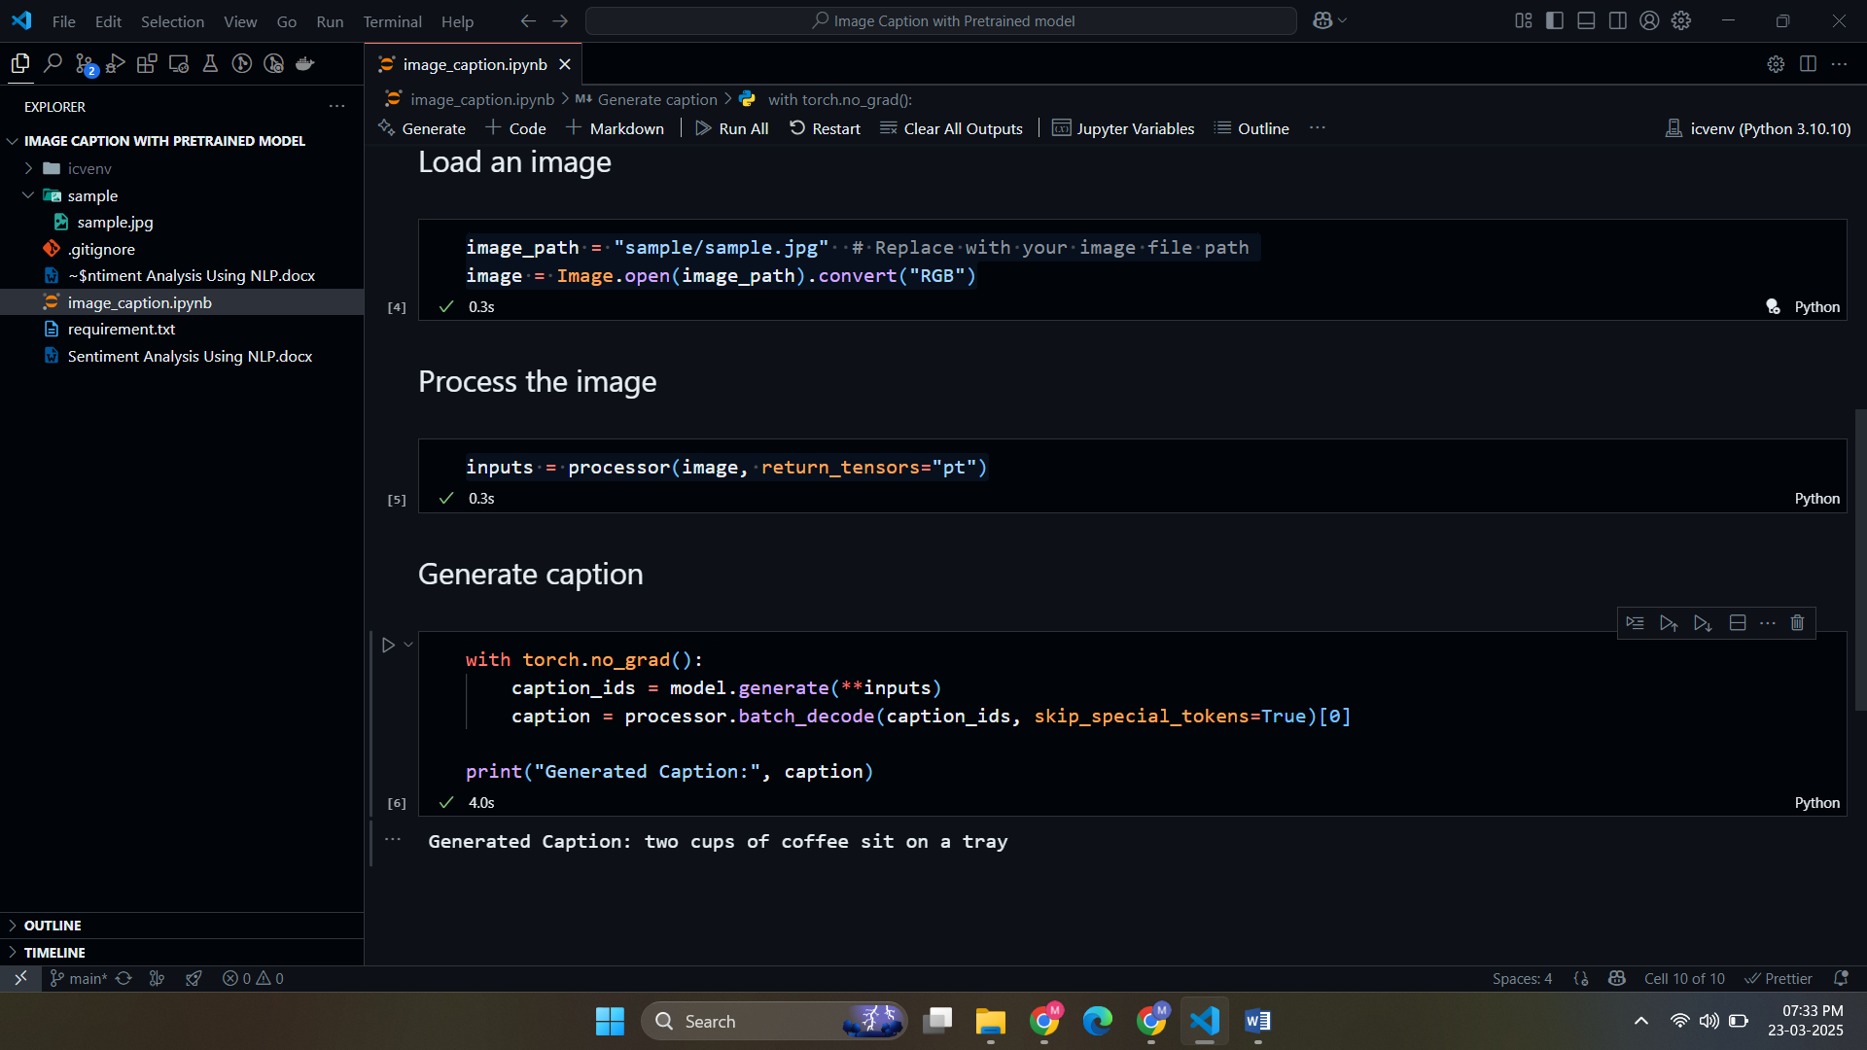

**Conclusion**

The **BLIP-based image captioning system** efficiently generates textual descriptions for images using a **pretrained vision-language model**. This approach eliminates the need for extensive training on custom datasets and provides **high-quality captions** using **transformer-based deep learning models**.

**Future improvements** include:

* Fine-tuning on **domain-specific datasets** for better contextual captions.
* Implementing **interactive applications** for real-time image captioning.
* Exploring **other multimodal learning models** like **CLIP and GPT-4 Vision**.

**References**

Vaswani, A. et al. (2017). Attention Is All You Need. Advances in Neural Information Processing Systems.

Radford, A. et al. (2021). Learning Transferable Visual Models From Natural Language Supervision. arXiv preprint arXiv:2103.00020.

Li, J. et al. (2022). BLIP: Bootstrapped Language-Image Pretraining for Unified Vision-Language Understanding. arXiv preprint arXiv:2201.12086.